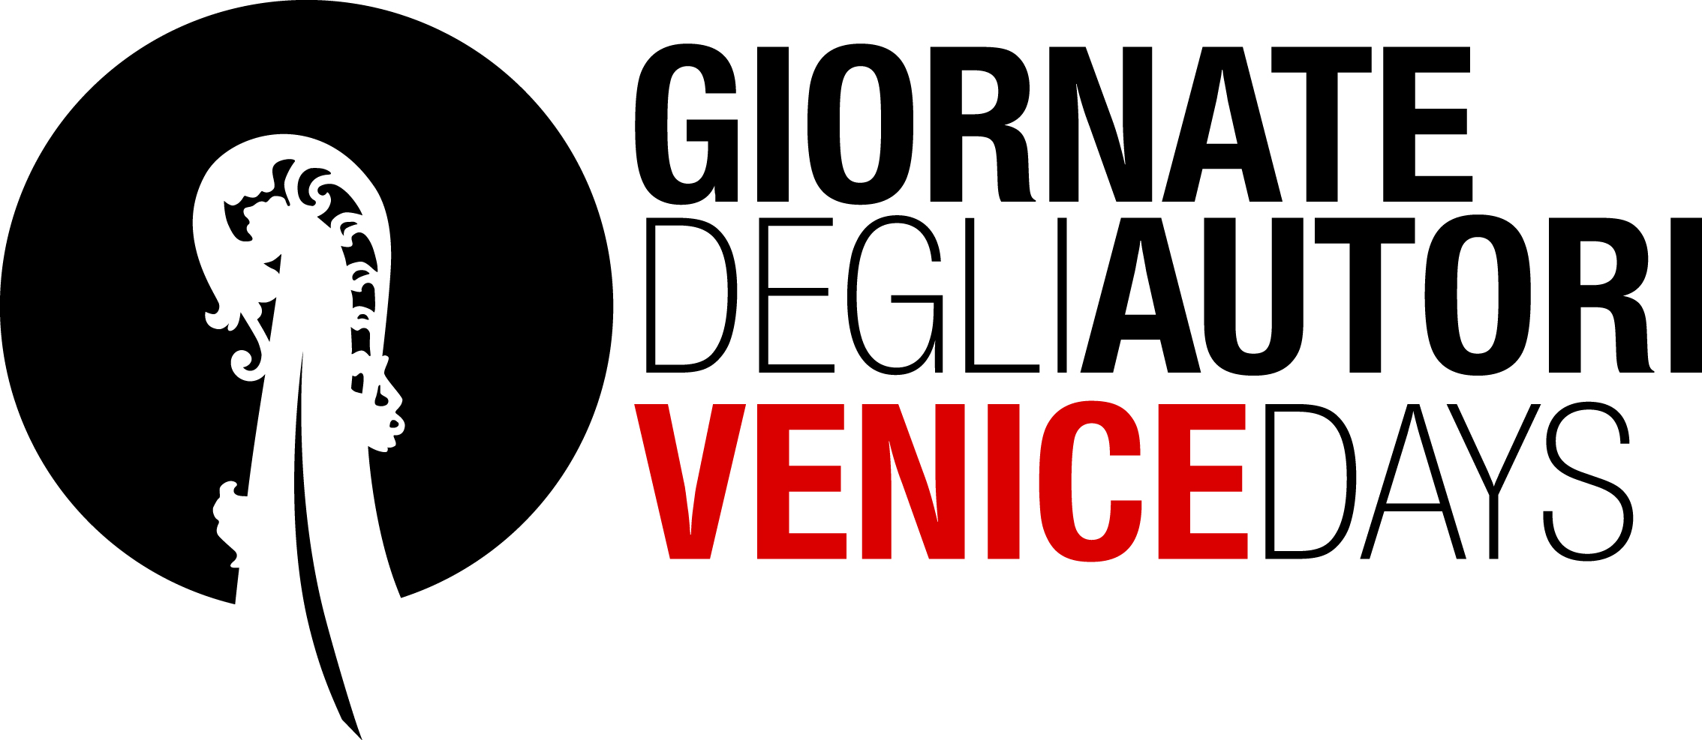

**CSC PRODUCTION - RAI CINEMA - BARBARY FILMS**

present

**LA RAGAZZA DEL MONDO**

**(Worldly Girl)**

a film by

**MARCO DANIELI**

with  
**SARA SERRAIOCCO**, **MICHELE RIONDINO**,

**MARCO LEONARDI**, **STEFANIA MONTORSI** and **LUCIA MASCINO**

with a special guest appearance by **PIPPO DELBONO**

produced by **CSC Production (Italy)** with **Rai Cinema (Italy)**in co-production with **Barbary Films (France)**in collaboration with **Fabio Piscopo**, **Annamode Costumes**, **F.lli Cartocci**, **DO Consulting & Production**, **Margutta Digital International**

a Bolero Film distribution

Film recognised as being of cultural interest, with contributions from the Italian

Ministry of Cultural Heritage and Activities and Tourism - Directorate General for Cinema

With the support of Regione Lazio

Fondo regionale per il cinema e l'audiovisivo

Italian press **Fosforo**Manuela Cavallari – mob.+39.349.6891660 – [manuela.cavallari@fosforopress.com](mailto:manuela.cavallari@fosforopress.com)

Giulia Santaroni – mob. +39.348.8224581 – [giulia.santaroni@fosforopress.com](mailto:giulia.santaroni@fosforopress.com)

Ginevra Bandini – mob.+39.335.1750404 – [ginevra.bandini@fosforopress.com](mailto:ginevra.bandini@fosforopress.com)

International Sales **Intramovies**Marco Valerio Fusco – mob.+39.335.7052982 – [marco.fusco@intramovies.com](mailto:marco.fusco@intramovies.com)

Manuela Tambascia – ph. +39.06.8077252 – [manuela.tambascia@intramovies.com](mailto:manuela.tambascia@intramovies.com)

**CREW**

**DIRECTOR** MARCO DANIELI

**STORYLINE and** MARCO DANIELI

**SCREENPLAY** ANTONIO MANCA

**DIRECTOR OF PHOTOGRAPHY** EMANUELE PASQUET

**EDITORS** ALESSIO FRANCO

DAVIDE VIZZINI

**ORIGINAL MUSIC** UMBERTO SMERILLI

**PRODUCTION DESIGN** LAURA INGLESE

**COSTUMES** CLAUDIA MONTANARI

GIULIA PAGLIARULO

**SOUND** GIULIANO MARCACCINI

**MIXING** ALESSANDRO CHECCACCI

**ART DIRECTOR** LORENZO CAPRONI

**ASSISTANT DIRECTOR** RENATO MURO

**PRODUCER** ELISABETTA BRUSCOLINI

**COPRODUCER** FABIO CONVERSI

**PRODUCTION and TECHNICAL DATA**

**PRODUCTION** CSC PRODUCTION  
 with RAI CINEMA  
 in co-production with BARBARY FILMS

**IN COLLABORATION WITH** FABIO PISCOPO  
 ANNAMODE COSTUMES  
 F.LLI CARTOCCI  
 DO CONSULTING & PRODUCTION MARGUTTA DIGITAL INTERNATIONAL

**ITALIAN DISTRIBUTION** BOLERO FILM

**RUNTIME** 104 minutes

**ITALIAN PRESS** FOSFORO

**INTERNATIONAL SALES** INTRAMOVIES - ph +39 06 807 72 52

**CAST**

**GIULIA** SARA SERRAIOCCO

**LIBERO** MICHELE RIONDINO

**CELESTINO** MARCO LEONARDI

Giulia's father

**COSTANZA** STEFANIA MONTORSI

Giulia's mother

**GIACOMO** PIPPO DELBONO

Jehovah's Witnesses congregation “Elder”

**PROF.SSA DONATI** LUCIA MASCINO

Maths teacher

**SIMONA** MARTINA CERRONI

Giulia's sister

**DANIELE** GIORGIO CARECCIA

crook

**LORETTA** MARIA CHIARA GIANNETTA

Giulia's friend

**MONICA** ALESSANDRA VANZI

Libero's mother

**RAFFAELE** ANDREA MAUTONE

Jehovah's Witnesses congregation “Elder”

**SYNOPSIS**

Giulia’s is a poised world, made of rigour and sacred texts, which fiercely excludes those who do not belong to it.

Libero's world is the world of all the others, of those who make mistakes, who fend for themselves looking for another chance and who love unconditionally.

When Giulia meets Libero, she realizes she can have another destiny, one she will have to choose and build.

Theirs is a very pure and unavoidable love story and the two kids embark on an intense period of life together, a choice that for Giulia entails the total exclusion from the Jehovah's Witnesses world she belongs to.

Libero will give Giulia the greatest gift of love: the freedom of belonging to the world, a new, bright world filled with the future.

**MARCO DANIELI**

**BIOGRAPHY**

Marco Danieli was born in 1976. He presently lives in Rome. He has been working as a director, author and editor in a numerous documentary and television productions while working as an independent filmmaker at the same time. In 2007, he got a degree in Film Direction from the Centro Sperimentale di Cinematografia (Italian National Film School). His short films have been selected in some of the most important international film festivals, such as the Venice film festival and the Tau Film Festival in Tel Aviv. Since 2011, he has also been working as a tutor at the Centro Sperimentale di Cinematografia in the course of Direction chaired by Daniele Luchetti.

“La ragazza del mondo” is his first feature film.

**FILMOGRAPHY**

2012 LUCE PROPRIA (documentary, B24 film production)  
2012 LE GEMELLE WRESTLER (commercial/short film, CSC Production for Takeda)  
2012 NESSUNA RETE (music video, Avvolte production)  
2011 POST (educational/short film, CSC Production for “Cinecittà si mostra”)

2010 HOTEL TERREMOTO (documentary)  
2008 IL SILENZIO DI CORVIALE (documentary, Comune di Roma production)  
2008 ULTIMA SPIAGGIA (short film, CSC Production and Mtv - Qoob production)  
2007 I CAPELLI DELLA SPOSA (short film, 35mm, CSC and Sardinia Media Factory)  
2006 PRIMAVERA (short film, 35mm, CSC production)  
2006 LA GIOIA DEGLI ALTRI (short film, 35mm, CSC Production)  
2005 MANICHINI (short film, CSC Production)  
2004 AMO’ (documentary, CSC Production)

**SARA SERRAIOCCO**

**CINEMA**

2015 - “L'ACCABADORA” by E. Pau  
2014 - “CLORO” by L. Sanfelice - Sundance Film Festival 2015  
2013 - “SALVO” by F. Grassadonia e A Piazza - Cannes Film Festival 2013 - Critics Week

**TELEVISION**

2014 - “FRANCESCO” by L. Cavani

2012 - “RIS ROMA 3” by F. Miccichè

**AWARDS**

2016 - SHOOTING STAR (Berlin Film Festival)  
2015 - PRIX D’INTERPRETATION FEMININE POUR LE FILM “CLORO”,

Festival du film d’Annecy  
2015 - BEST RISING ACTRESS AWARD for “CLORO”

at the 20th Roseto Opera Prima Film Festival  
2015 - BEST ACTRESS AWARD "Shorts International Film festival " for “CLORO”

2015 - BEST ACTRESS AWARD at the "Piazze di Cinema" Cesena for “CLORO”  
2015 - BEST ACTRESS AWARD at the "Gallio film festival" for “CLORO”  
2014 - KINEO AWARD - young promising actors- 71st Venice Film Festival  
2014 - ITALIAN GOLDEN GLOBE for BEST ACTRESS for “SALVO”  
2014 - GUGLIELMO BIRAGHI AWARD for best up-and-coming actors of the year  
2013 - FLAIANO - PEGASO D’ORO AWARD as best budding actress for “SALVO”  
2013 - VITTORIO DE SICA AWARD  
2013 - BEST ACTRESS AWARD - Magna Grecia Film Festival  
2013 - GOLDEN GRAAL - SPECIAL PRIZE  
2013 - TERTIO MILLENNIO FILM FESTIVAL - REVELATION AWARD for “SALVO”

**MICHELE RIONDINO**

**CINEMA**

2016 - “FALCHI” by T. D’Angelo  
2014 - “WONDROUS BOCCACCIO” by P. e V. Taviani

2014 - “SENZA LASCIARE TRACCIA” by G. Cappai  
2013 - “LEOPARDI” by M. Martone  
2012 - “DORMANT BEAUTY” by M. Bellocchio  
2012 - “STEEL” by S. Mordini  
2011 - “DRIFTERS” by M. Rovere  
2011 - “SCATTERED CLOUD” by S. Di Biagio  
2010 - “WE BELIEVED” by M. Martone  
2010 - “HENRY” by A. Piva  
2008 - “FORT APACHE NAPOLI” by M. Risi  
2008 - “TEN WINTERS” by V. Mieli  
2008 - “MARE PICCOLO” by A. di Robilant  
2007 - “THE PAST IS A FOREIGN LAND” by D. Vicari

2003 - “VITE A CONFRONTO” by M. Puccioni (corto)  
2002 - “LOVE, LIES, KIDS... & DOGS” by E. Giorni

2000 - “GABRIELE” by M. Angeloni

**TELEVISION**

2014 - “THE YOUNG MONTALBANO 2” by G. M. Tavarelli  
2014 - “PIETRO MENNEA, LA FRECCIA DEL SUD” by R. Tognazzi

2011 - “THE YOUNG MONTALBANO” by G.M. Tavarelli  
2010 - “IL SEGRETO DELL'ACQUA” by R. De Maria  
2005 - “GIORNI DA LEONE 2” by F. Barilli  
2005 - “DISTRETTO DI POLIZIA 5” by L. Gaudino  
2003 - “DISTRETTO DI POLIZIA 4” by M. Vullo  
2002 - “DISTRETTO DI POLIZIA 3” by M. Vullo  
2002 - “INCANTESIMO” by Cane & Sherman  
2001 - “COMPAGNI DI SCUOLA” by T. Aristarco e C. Norza  
2000 - “CASA FAMIGLIA” by R. Donna

**THEATRE**

2016 - “JULIUS CAESAR” by A. Rigola

2015/16 -“EURIDICE E ORFEO” by D. Iodice

2013 - “SIAMOSOLONOI” di C. Bordeaux

2012 - “LA VERTIGINE DEL DRAGO” di M. Riondino

2012 - “THE FOOL ON THE HILL” di M. Andreoli

2010 - “VIVA NIATRI” di Ferracani-Pilli-Riondino

2006 -“CANI DI BANCATA” di E. Dante

2003 - “COMPENDIO GENERALE” di M. Andreoli

2003 - “A VIEW FROM THE BRIDGE” di G. Patroni Griffi

2002 - “MOGANO” di M. Andreoli

2002 - “THE BACCHAE” di A. Buchelli

2002 - “SCRITTI METROPOLITANI” di F. Colangelo

2002 - “MEZZANOTTE” di M. Andreoli

2001 - “CENTO” di M. Andreoli

2000 - “LA MACCHINA INFERNALE” di G. Bovini

2000 - “MACBETH” di M. Bellocchio

2000 - “L’ALIBI DI DIO” di F. Randazzo

2000 - “SLEEPING AROUND” di M. Carniti

1999 - “UN LEGGERO MALESSERE” di A. Buchelli

1999 - “OEDIPUS THE KING” di A. Rallis

1999-2000 “ANTIGONE” by M. Fabbri  
1997 - “WAITING FOR GODOT by M. Maggiori

**AWARDS**

2013 - EXCELLENCE AWARD  
2012 - BEST ACTOR at the Rome Fiction Festival for “THE YOUNG MONTALBANO”

2012 - CINEMA TALENT AWARD  
2011 - SILVER RIBBON OF THE YEAR for “WE BELIEVED”  
2010 - GUGLIELMO BIRAGHI AWARD  
2010 - SHOOTING STAR (Berlin Film Festival)  
2009 - TARGA ANEC CLAUDIO ZANCHI (Sorrento)  
2009 - GOLDEN GRAAL - RISING STAR  
2009 - MIAMI FILM FESTIVAL - BEST ACTOR

2008 - L.A.R.A. AWARD Rome Film Fest - BEST ACTOR